Paper Fong: Analysing the behaviour finance impact of ‘fake news’ phenomena on

financial markets: a representative agent model and empirical validation

1)

How can we modelize fake news? And how it impacts the financial markets? (returns of a company)

2)

The authors made an empirical experiment to test their hypothesis:

As existing models and literature remain insufficient in fully explaining how fake news can contradict the efficient-market hypothesis and rationally have impacts on financial markets and prices, a new full model needs to be built to effectively achieve this.

As shown in the “Literature review” section, prior literature proves that fake news empirically generates initial price impacts on financial securities (defined in this paper

as fake news’ primary impact). As previously discussed, these represent price overreactions that contradict the efficient-market hypothesis—which this paper aims to formally rationalise through an economic model.

Prior literature and models of price underreactions and overreactions fail to satisfactorily fully explain why or how this primary impact can arise in financial markets. Therefore,

to reconcile this with empirically-observed short-term underreactions to real news,

this section proposes an original unified representative agent model of price underreaction/ overreaction. Motivated by established behavioural finance biases, the model is

driven by bounded rationality over uncertainty in information veracity.

# Setting up the model

The model uses a sole representative investor, which therefore sets the security’s market prices based on

their personal valuation, P.

News shocks are simplified to convey direct information on the security’s exogenously generated true

value.

For this model, this is akin to each investor simultaneously receiving each news shock through the same (and only) news outlet—so the only consideration is the actual shock itself.

The model additionally simplifies news shocks into two distinct extremes: real and fake. Real shocks in this model are accurate and unambiguous numerical indicators of a security’s value, occurring whenever this value updates. Fake shocks in this model convey similar numerical indicators of a security’s value, but are conversely purely spurious.

As this model’s news shocks directly convey a security’s numerical value, only one is ever contemporaneously accurate; the rest must be fake or outdated.

The model starts at time 0 with a real news shock, I0 , forming the initial P . This valuation evolves with subsequent news shocks, based on a weighted average.

News shock, In , occurs at period t = n , where n _ {0, . . . ,M} . M represents the period

of the latest news shock. The model assumes a maximum of one news shock per period.

# Information weight determinants: base model

The agent’s security valuation, P , is a weighted average of news shocks, In , weighted by their weighted shares, n:

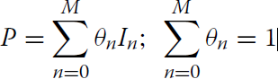

Shares

News shock

The weighted shares for individual news shocks are determined by the size of their information weights, Sn , relative to the sum of all information weights, so the weighted shares sum to 1:

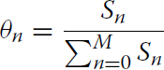

Size of their information weight

The information weights, Sn , represent the relative importance of the different news shocks to the agent. Therefore, P represents a weighted average of the valuations conveyed by the news shocks, weighted by their relative importance to the agent.

Sum of all the information weight = 1

We know gonna see three terms:

-base value (a)

-irrelevant factor (b)

-time decay factor (c) (a)*(b)*(c) = information weight

# Base value

The primary determinant of a news shock’s information weight is its base value

This is determined by the binary variable representing

the news shock In ’s nature, n ∈ {0, 1} , and the investor’s ability to distinguish this

nature,  ∈ [0.5, 1]:



n = 1 indicates In is real

n = 0 indicates In is fake.

p= 1 indicates an agent perfectly able to distinguish between real and fake news,

p = 0.5 indicates an agent perfectly unable to distinguish between the two.

Sn(base) measures the agent’s certainty of the news shock’s veracity.

If agents are perfectly sure that In is real, they will value In fully as the security value => Sn(base) = 1.

If they are perfectly sure that In is fake, they will be certain of its spuriousness and ignore it => Sn(base) = 0.

Therefore, as p increases, agents place more weight on real news and less on fake news.

However, as p decreases towards 0.5, the agent grows more uncertain of which type they face, optimizing over this constraint by placing increasingly similar middling weights on both.

In this paper’s model, real and fake news only differ in credibility, represented by n

The model therefore assumes that real news shocks are fully credible (n = 1), while fake news shocks are completely non-credible (n = 0).

This paper therefore assumes that agents ideally fully rely on credibility, n , to determine their value of a security, but are constrained by their ability to actually distinguish n .

Thus, as p determines the agent’s ability to distinguish n. P determines how much agents rely on credibility to determine confidence.

Therefore, the lower an agent’s p, the more constrained they are from relying on credibility; making them more underconfident in real news and overconfident in fake news.

# Irrelevance factor or old news

With perfect ability to distinguish information veracity, p = 1 , previous news shocks should become immediately irrelevant once updated real information is introduced; or remain unaffected if new fake information is introduced.

without p = 1, agents are not certain of a shock’s veracity.

old shocks grow increasingly irrelevant over time. For real news, this could be because updated real

information’s credibility remains persistently robust; so over time an updated real shock’s veracity can be increasingly relied on.

Since older information naturally becomes harder to recall over time, after updated information is introduced. Therefore, older news shocks grow increasingly irrelevant, conditional on the agent’s certainty in the updated shock’s veracity.

These dynamics are modelled by an irrelevance factor:

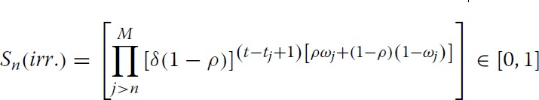

For each more updated news shock, Ij>n , introduced, In ’s weight is multiplied by an additional irrelevance

term; which individually and jointly decrease (or at most maintain) In ’s weight, since each term ∈[0, 1].

Each irrelevance term can be decomposed into four components: the irrelevance

multiplier,  ∈ [0, 1]; the investor’s inability to distinguish between real and fake news, (1 − p) ∈ [0, 0.5] ; the time since news shock Ij>n was introduced, (t − tj + 1)≥ 1 ; and the base value of updated news shock Ij>n , [ pj + (1 − p)(1 − j)] ∈ [0, 1].

An investor better at distinguishing information veracity relies less on past information, decreasing In ’s weight further for every new shock introduced, through a lower (1 − p); which can be amplified by a non- unitary , to represent a greater bias against old news. At the limit, a perfectly competent agent with

(1 −p)= 0 , fully discounts In once a new real shock occurs.

This base value and (1 − p) are ∈ [0, 1], so the irrelevance term increases towards 1 as certainty in Ij>n ’s

veracity decreases.

At the limit, with perfect certainty in Ij>n ’s spuriousness, Ij>n ’s base value equals 0, so Ij>n ’s overall

irrelevance factor equals 1; so, Ij>n leaves In ’s information weight unaffected.

with perfect certainty in Ij>n ’s veracity, Ij>n ’s base value equals 1 and (1 − p) equals 0, so In is fully discounted

This starts at 1 upon Ij>n ’s introduction, since the introduction of new shocks immediately affects the relevance of old information.

# Time decay factor of spurious information:

Spurious information’s credibility decays over time since, without any solid supporting evidence, spurious

rumours progressively lose believability.

empirically demonstrating that, even without outright debunking, fake news’ average initial price impacts

on small firms fully reverse within a year.

This is represented through a spurious information time decay factor,∈[0, 1]:

Une image contenant texte, montre, jauge  Description générée automatiquementn: credibility of the news

=0 => spurious information is perfectly temporary and decays after fully one period

=1 => spurious information suffers no additional time decay

This is modified by (1 − n) in the exponent, neutralizing Sn(time decay) into 1, leaving In ’s information

weight unaffected unless In is fake.

This factor is amplified by the (t − tn) term in the exponent, diminishing In ’s weight

further as more time passes since In ’s introduction (if In is spurious).

# Information weight determinants: fake-news specific

This paper also proposes an extended ‘full’ model, incorporating fake news-specific effects drawn from existing literature on fake news’ characteristics. Therefore, two additional determinants of information weight are included for the full model: the virality factor, and the fake news uncertainty factor.

# Virality factor of fake news

Fake news is structured to shock and convince, maximising initial impacts to spread faster and deeper than real news.

This is represented through a fake news virality factor,  ≥1:

=1 => indicate that fake news in the model is unaffected by virality effects. This factor is also modified by (1-n) in the exponent.

This term ensures that, unless In is fake and _n = 0 , the entire Sn(viral) factor is neutralized to Sn(viral) = 1 , which thereby leaves In ’s information weight unaffected.

This factor is also modified by the agent’s inability to distinguish information veracity,(1 − p) , in the exponent; since less capable agents are more susceptible to fake news virality.

In comparison, the base model ignores fake news’ differentiating characteristics from real news,

and assumes that “strength” remains equal across both fake news and real news shocks of equal magnitude. As such, this is effectively represented in the full model by the virality factor, with fake news shocks having greater “strength” than real news shocks, as long as  > 1.

# Fake news uncertainty factor

As we know fake news decreases responsiveness to subsequent news shocks. This enters the model as an investor becoming less able to distinguish information veracity upon learning of fake news’ presence.

This fake news uncertainty effect is modelled through a new equation for the investor’s

ability to distinguish between real and fake news, p:

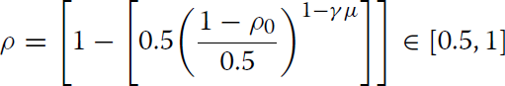

Where:

-pO ∈ [0.5, 1] is initial ability

-(1 − p0) ∈ [0, 0.5] measures initial inability

-  ∈{0, 1} is a binary variable indicating fake news’ signaled presence in the security

-μ ∈ [0, 1] represents the fake news uncertainty factor

This therefore models the fake news uncertainty effect as a simple modifier affecting the investor’s

percentage inability, from which the new investor ability can be rederived.

(1 − μ) determines the magnitude of the fake news uncertainty effect, depending on the agent becoming

aware of fake news’ presence.

If = 0, fake news’ presence is not signaled, transforming the uncertainty exponent

to 1, so investor ability remains unchanged po=p

 = 1 indicates fake news’ signaled presence, so the uncertainty exponent would be ∈[0, 1]

If both the uncertainty exponent and the percentage investor inability are ∈ (0, 1) , this increases the percentage investor inability, decreasing p < p0.

The rate of decrease depends on μ. As μ increases, the uncertainty exponent decreases, further decreasing p. If μ = 1, discovering fake news renders the agent perfectly unable to distinguish information veracity. If μ = 0, this has no effect.

# Complete Model

The representative agent’s security valuation, P , is formed as follows:

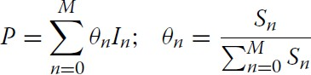

# Base model

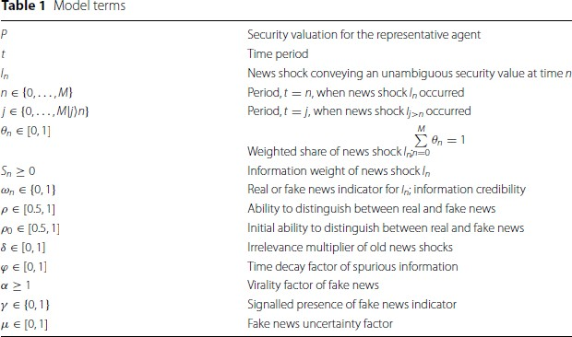

**Full model:**

The full model’s information weight, formed by the determinants in the “Information weight determinants: base model” section, and the fake news-specific determinants in the “Information weight determinants: fake news” section, is given as:

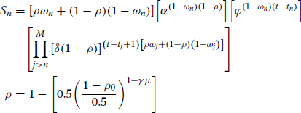

***Impulse***-***response functions :***

* A real news shock, I1
* A fake news shock, I1
* A fake news shock, I1 , followed by a debunking real news shock, I2

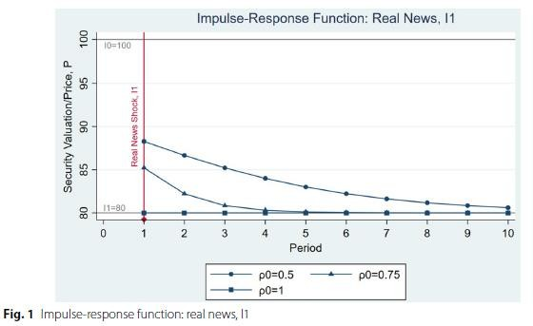

I0 = 100 , so P starts at 100

I1 = 80

I2 = 100 = I0

A debunking shock, I2 , is used, since debunking represents a subsequent

real news shock which contradicts prior fake news, and signaling the presence of prior fake news; thereby activating the fake news uncertainty factor.

The impulse-response functions are modelled with varying initial investor ability, p0

Base Model:

* = 1; no additional bias against old news
* = 0.6

Full Model :

* = 5
* = 1; after debunking shock, I2, signals fake news’ prior presence;  = 0 otherwise
* = 0.5

# One real news shock

Fig. 1, display an initial shift (down from I0 = 100) in P when the real news shock occurs, for all values of p0 . This is a full shift to I1 = 80 when p0 = 1; with increasing underreaction for lower values of p0.

Underreaction is resolved over time, moving P towards I1 = 80. The rate this occurs at increases with larger

p0 values.

This matches the model’s theorised dynamics, where less capable investors underreact more to real news, due to conservatism bias from uncertainty over I1 ’s veracity and qualitatively matches empirical underreactions to real news shocks.

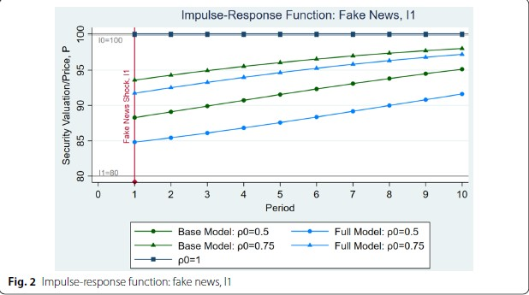

# One fake news shock

Both models are identical when _0 = 1 as the agent is perfectly unaffected by fake news;

P remains at I0 = 100.

the full model (light blue) only adds the virality multiplier, . This amplifies the fake shock’s information weight, compared to the base model (green); weighting the full model closer to I1 = 80 in each period and p0 value.

Fig. 2, display an initial shift (down from I0 = 100 ) in Pwhen the fake news shock occurs, for P0 < 1 ; representing an overreaction to fake news.

This decreases in p0 , as more capable investors overreact less to fake news, due to greater

certainty in I1 ’s spuriousness; matching the “Information weight determinants: base model” section’s

theorised dynamics.

The initial shifts for the base model are weaker at every _0 , compared to Fig. 1’s shifts under equivalent real news; except when _0 = 0.5 , where agents cannot distinguish information veracity, and initial shifts are equal.

P0 > 0.5 , as they show that fake news’ initial price effects are empirically smaller than equivalent real news’; indicating that agents empirically can partially distinguish information veracity. Comparatively, the full model is amplified by virality, so the initial shift

could be greater than equivalent real news’, depending on .

the initial overreaction reverses over time; moving P back towards I0 = 100 . Here, the time decay factor, , overrides the irrelevance factor in I0 ’s information weight,

degrading the fake I1 ’s credibility over time

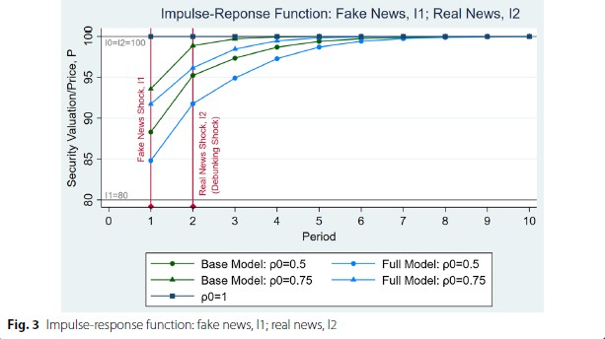

# One fake news shock and one real news shock

Both models are identical when _0 = 1 as the agent is perfectly unaffected by fake news;

P remains at I0 = 100.

For a fake shock followed by debunking, the full model (light blue) adds both the virality multiplier,  , and the fake news uncertainty factor.  enters first, amplifying the full model’s fake shock information weights, compared to the base model (green), identically to Fig. 2. After debunking, I2 , occurs and signals fake news’ prior presence, the uncertainty factor enters the full model. This weakens the reversion to I0 for p0 =

0.75 , as awareness of fake news’ presence renders the agent less able to distinguish information veracity; so p < p0 . The uncertainty factor has no effect when p0 = 0.5 or 1 , as perfectly competent agents are unaffected by fake news and perfectly incompetent agents cannot worsen.

when _0 < 1 , this recursion is not immediate. P persistentlydeviates from I0 several periods after debunking, as agents underreact to I2 due to conservatism bias from uncertainty over I2 ’s veracity.

Underreaction to I2 increases with weaker spurious information time decay, , and lower initial investor capability, p0 ; as well as with the full model’s fake news-specific effects. Specifically, greater fake news virality,  , and greater fake news uncertainty effects, μ , increase underreactions to the debunking real news shock; by persistently boosting the prior fake shock’s information weight, and worsening the agent’s ability to distinguish information veracity (upon awareness of fake news), respectively.

Therefore, the full model (driven by these fake news-specific effects) predicts a novel secondary fake news impact: that fake news in a security amplifies underreactions to all subsequent real news for the security.

**Data description**

***The 2019 Chinese ADR delisting threat***

This paper identifies the 2019 Chinese ADR Delisting Threat as a clear example of fake news and debunking.

This specific event and data set was used, as it was one of the only events which allowed for the full model to be evaluated over a large sample of testable security price data.

The event’s timeline proceeds as follows:

*11:36am EDT, Friday, September 27, 2019* A Bloomberg News article states that the Trump administration is considering “delisting Chinese companies from U.S. stock exchanges”, citing an anonymous source “close to the deliberations”

*5:06 pm EDT, Saturday, September 28, 2019* A Bloomberg News article states that

U.S. Treasury official Monica Crowley publicly announced via email that “the administration

is not contemplating blocking Chinese companies from listing shares on

U.S. stock exchanges at this time” debunking Friday’s rumour.

This was a high-profile event, which would have reasonably affected all Chinese companies with U.S.-listed shares, of which there were 156 as of February 25, 2019. Therefore, this was an

unambiguous example of fake news impacting a large number of public equities, before subsequent debunking.

# Event study methodology:

***Estimating normal returns***

Rit is security i ’s return at time t. Rmt is the market return at time t

it is a zeromeanerror term.

i and i are parameters of the market model that would be estimated via OLS regression in the estimation window prior to the event window.

2i represents the market model variance.

***Abnormal returns and cumulative abnormal returns***

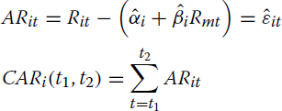

ARit is security i ’s abnormal return at time t .

CARi(t1, t2) is security i ’s cumulative abnormal return, covering t1 to t2 .

 is the estimated market model relationship predicting security i ’s normal return at time t

The cross-sectional average abnormal returns (AARs) and cumulative average abnormal returns (CAARs) across N sample firms, are calculated as:

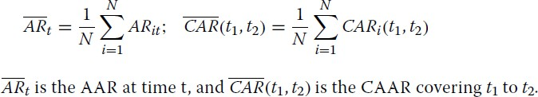

# Hypothesis testing

The traditional t-test statistics for the ARs, CARs, AARs, and CAARs are calculated by dividing their respective values by their respective standard deviations

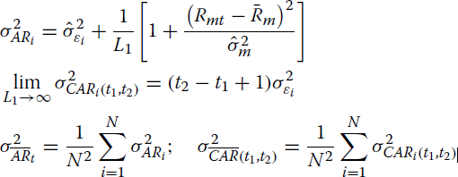

AR variance is the market model sample variance  adjusted for forecast error

L1 is the length of the estimation window

 average market return over the estimation window sample market variance over the estimation window

With large estimation windows, the forecast error asymptotically converges to zero,.



To test for fake news’ cross-sectional abnormal price impacts over time and postdebunking, this paper focuses on testing CAARs. The CAAR t-test statistic, covering t1 to t2

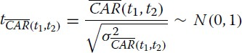

Under the null hypothesis, CAARs theoretically have zero-mean normal distributions.

This test statistic standardized the CAARs, to compare against the standard normal twotailed critical values.

If tCAR(t1,t2) ’s absolute value exceeds the critical values, the null hypothesis (that tCAR(t1,t2) is insignificant)

can be rejected, and the event’s cumulative effect can be shown as persistently significant until t2.

# Results

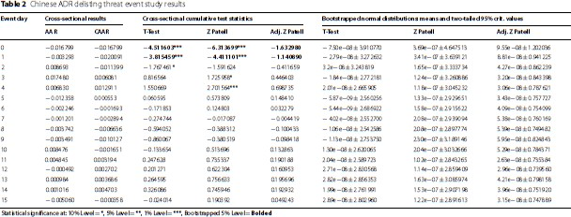

The Adjusted Patell test results with bootstrapped critical values, in Table 2, can be interpreted as testing

fake news’ abnormal price effect, cumulative over the debunking shock, for significance over time.

Graphed in Fig. 4, these results confirm significant abnormal price effects. Specifically, the Adjusted Patell test values on September 27 and 30 are − 1.63 and − 1.14 respectively, exceeding their bootstrapped two- tailed 95% critical values (± 1.20 and ± 0.94 respectively); represented in Fig. 4, as both results fall below the bootstrapped region.

All subsequent results fall within the bootstrapped region, so their insignificance cannot be rejected; implying that the initial fake news abnormal price effect is neutralised after September 30. Table 2 indicates that these dynamics are all also supported by the weaker t-test and Patell test results.

indicates that fake news generates a significant initial abnormal negative price effect. This gradually reverses but remains significant for three calendar days post-debunking.

This robustly indicates a significant initial overreaction to fake news, and significant underreaction to debunking; qualitatively matching the model dynamics.

the empirical results suggest that the post-debunking underreaction is too protracted to be accounted for

solely by the base model. According to the base model, fake news’ initial price impact should be

significantly smaller than equivalent real news’ initial price impact, if p0 > 0.5

The empirical evidence thus supports the full model’s predicted secondary fake news impact: that fake news in a security amplifies underreactions to subsequent real news in the security. Combined with the qualitative accuracy of the model’s dynamics for debunked fake news shocks, and standalone real and fake news shocks, this validates this paper’s model of underreaction/overreaction, and its explanation of fake news’ financial impacts.

# Opinion on the result

Thanks to the results we can see how the financial markets reacts to the real/fake news (reactions). And how the model can predict the impact of the fake news in the financial markets (economic explanation).

# Contributions

This paper seeks to provide a formal economic explanation of how fake news can generate impacts in financial markets, through a combination of theory and empirics.

Propose an original formal economic model to explain the empirically- proven impacts that fake news can have on financial markets. An extended version of the model also provides a hypothesis for an additional novel impact of fake news in financial markets which has not been formally analysed by prior literature— which is validated along with the overall model’s qualitative accuracy through empirical testing.

Established behavioural finance biases are introduced to explain and reconcile empirically observed price overreactions to fake news with empirically observed price underreactions to real news.

Second This model is then extended with established fake news-specific characteristics and predicts a new secondary impact of fake news: that fake news in a security amplifies underreactions to subsequent real news for the security.

Then the model’s dynamics and predictions are evaluated through a large-sample empirical event study. This is conducted as a novel event study over the 2019 Chinese ADR Delisting Threat fake news and debunking event.

The empirical results indicate statistically significant price overreactions to fake news and price underreactions to debunking over the event and provide qualitative support for the model’s prediction including the proposed secondary fake news effect.

# Critiques:

Great paper that thanks to statistical method prove how fake news impact the financial market and how investors react to it (debunking).